Meme Project
An important part of the course is your ability to apply economic concepts to real world events outside of the classroom. Such ability shows a comprehension of a topic. An important part of real life is being able to use memes. Facebook, reddit, news sites, and blogs are littered with memes.
I want you to build a meme that incorporates economic knowledge. Find an issue, event, or just something happening in your life and respond to it using a meme. The issue itself does not have to be strictly based in economics; however, your meme should be related to something that we studied in this class.
Your meme should be appropriate for school and relate to a topic covered in your textbook or in class. Extra points will be awarded for creativity and humor.
Included with your meme, there must be a 1-2 page paper describing the issue that the meme addresses and, in detail, the economic concept that the meme invokes.

Due Date:
December 4th (in class)

Meme Examples:
In response to the argument that regulating the Internet industry will cause market distortion:
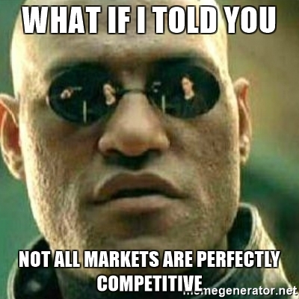
In response to a new tax on cat food:
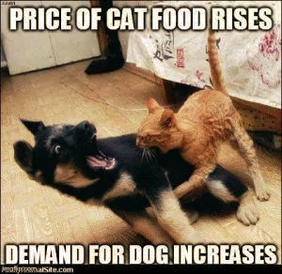
In response to a news report on doctors from low ranked universities on average prescribing more opioids than those from high ranked universities:
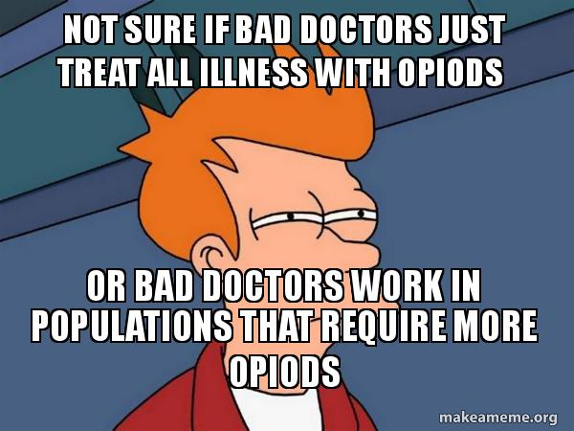

Trying to resell textbooks after the semester ends:
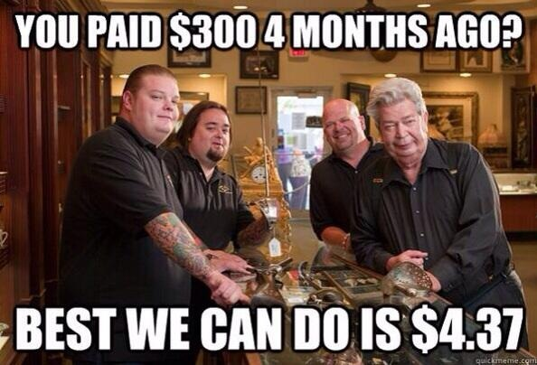

Sites for making meme’s:
https://memegenerator.net/
https://makeameme.org/

