Homework 1
Directions: Complete all problems. Use graphs when necessary and show all steps. Half of the credit (5 points) for this assignment will be based on completion of every problem with an honest effort. The other half of the credit (5 points) will be based on correctness. I will grade 2 problems at random for correctness. You may work with one other person. If you do, please only turn in one copy with both of your names on them.

- It costs a company $35,000 to produce 700 graphing calculators. The company’s cost will be $35,070 if it produces an additional graphing calculator. The company is currently producing 700 graphing calculators.
  - What is the company’s average cost?

  - What is the company’s marginal cost?

  - A customer is willing to pay 60 for the 701th calculator. Should the company produce and sell it? Explain why or why not.

- Use the following figure:

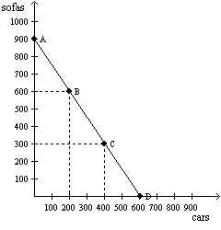

  - Consider the production possibilities frontier for an economy that produces only sofas and cars. The opportunity cost of one sofa is

  - Consider the production possibilities frontier for an economy that produces only sofas and cars. The opportunity cost of one car is

  - As the economy moves from point A to point D, is the opportunity cost of cars increasing, constant, or decreasing?

- Are people rational? Explain why or why not.

- Economist at which organization determine the costs of proposed government policies?

- Draw a production possibilities frontier showing increasing opportunity cost of hammers in terms of horseshoes.
  - On the graph, identify the area of feasible outcomes and the area of infeasible outcomes.

  - On the graph, label a point that is efficient and a point that is inefficient.

  - On the graph, illustrate the effect of the discovery of a new vein of iron ore, a resource needed to make both horseshoes and hammers, on this economy.

  - On a second graph, illustrate the effect of a new computerized assembly line in the production of hammers on this economy.

- The production possibilities frontiers below show how much Greg (Left graph) and Catherine (Right graph) can each produce in 8 hours of time.
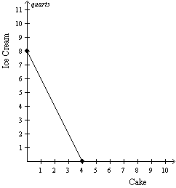 | 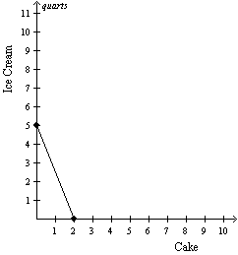
- What is Greg’s opportunity cost of producing 1 ice cream? 1 cake? Be sure to include the units in your answer.

- Who has the comparative advantage in producing ice cream? Who has the comparative advantage in producing cake?

- Who has the absolute advantage in producing cake? Who has the absolute advantage in producing ice cream?

- A group of buyers and sellers of a particular good or service is called a

Table 4-15
The following table shows the number of cases of water each seller is willing to sell at the prices listed.
Price per case | Alpine Springs | Brook Mountain | Cascade Waters | Dew Good
$0.00 | 0 cases | 0 cases | 0 cases | 0 cases
$3.00 | 100 cases | 40 cases | 60 cases | 100 cases
$6.00 | 200 cases | 80 cases | 120 cases | 200 cases
$9.00 | 300 cases | 120 cases | 180 cases | 300 cases

- Refer to Table 4-15. If all four suppliers operate in this market, what is the market quantity supplied when the price is $6.00 per case?

- Refer to Table 4-15. Assuming these are the only four suppliers in this market, the function for market supply can be written as Q^{S}=

Figure 4-30
​
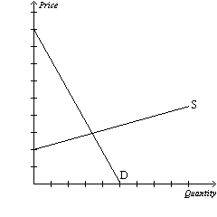

- Refer to Figure 4-30.
  - In this market for iPhones, the technology improves while all other factors remain constant. Draw this shift on the graph.

  - How does equilibrium price change? Equilibrium quantity?

  - Now, more consumers come into the market. Draw this shift on the graph. Explain how this new equilibrium price and quantity (after both this shift and the shift from part a.) differs from the original equilibrium.

