Homework 3
Directions: Complete all problems. Use graphs when necessary and show all steps. Half of the credit (5 points) for this assignment will be based on completion of every problem with an honest effort. The other half of the credit (5 points) will be based on correctness. I will grade 2 problems at random for correctness. You may work with one other person. If you do, please only turn in one copy with both of your names on them.

- Using the graph below, answer the following questions about hammers.
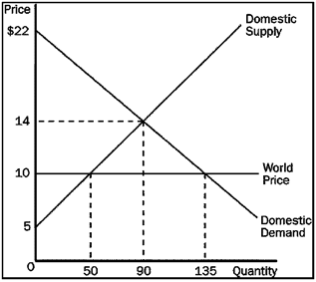
- What is the equilibrium price and quantity before trade?

- What is the equilibrium price, quantity consumed, and quantity produced by domestic firms after trade?

- What is the consumer surplus, producer surplus, and total surplus after trade?

- How much has this society benefitted from trade? Be specific.

- Suppose domestic demand and domestic supply in a market are given by the following equations:

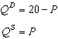

- With no trade allowed, how much are consumer surplus, producer surplus, and total surplus in this market?

- Suppose the world price in this market is $8 per unit. If the country allows free trade, will the country import or export this good, and how many units will be imported/exported?

- Suppose the world price in this market is $8 per unit. If the country allows free trade, by how much do consumer surplus, producer surplus, and producer surplus change?

- Using the graph, assume that the government imposes a $1 tariff on hammers. Answer the following questions given this information.
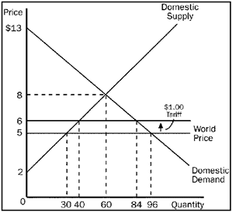
- What is the domestic price and quantity demanded of hammers after the tariff is imposed?

- What is the quantity of hammers imported after the tariff?

- What would be the amount of producer surplus after the tariff?

- What would be the amount of government revenue because of the tariff?

- What would be the total amount of deadweight loss due to the tariff?

- Google enters into the developing country, Freedonia, and opens up a production plant. They employ citizens of the Freedonia and produce self-driving cars. Will this help Freedonia grow economically? Why or why not.

- The demand curve for fire extinguishers slopes downward and the supply curve for fire extinguishers slopes upward. The production of the 500th fire extinguisher entails the following:
• a private cost of $10;
• an external cost of $0;
• a private value of $9;
• an external benefit of $3.

- Does the production of fire extinguishers convey a positive externality, a negative externality, or neither?

- What is the social value of the 500th fire extinguisher?

- In order to reach the social optimum, should fire extinguishers be taxed or subsidized? What is the appropriate amount of the tax or subsidy on each fire extinguisher?

- Is the socially-optimal quantity of fire extinguishers less than, equal to, or greater than 500? Explain.

- Patents allow firms to collect additional profit from their inventions; however, they raise the prices of products that are patented by eliminating competition. Should we, as a society, continue to have patents? Why or why not? Be sure to use externalities in your answer.

- Using a supply and demand diagram, demonstrate how a negative externality leads to market inefficiency. How might the government help to eliminate this inefficiency?

- Why do wild salmon populations face the threat of extinction while goldfish populations are in no such danger?

- Consider the following goods:
• fire-protection services provided by a fire department
• a beautiful mural on the outside wall of a fire station
• a firefighter’s helmet

- Which of these goods is the best example of a private good? Briefly explain.

- Which of these goods is the best example of a public good? Briefly explain.

- Which of these goods is the best example of a club good? Briefly explain.

- Consider a small family wheat farm. List some examples of explicit costs of farming.

- Describe the relationship between average variable cost and average total cost. How are the general shapes of the AVC and ATC curves related?

- Use the following table:
Labor | Output | Marginal  Product | Variable  Cost | Fixed  Cost
0 | 0 | -- | $0 | $5
1 | 100 | 100 | $5 | $5
2 | 250 |  | $10 | $5
3 | 350 |  | $15 | $5
4 |  | 50 | $20 | $5
5 |  | 25 | $25 | $5
6 | 430 |  | $30 | $5
- What is the marginal product of the second worker?

- What is the total output of five workers?

- What is the marginal product of the sixth worker?

- What is the average total cost of producing 425 units of output?

- Suppose that a small family farm sold its output for $100,000 in a given year. The family spent $25,000 on fuel, $40,000 on seed, fertilizer, and pesticides, and $25,000 on equipment, including maintenance. The family members could have earned $20,000 working at other occupations.

- What is the accounting profit for the family farm?

- What is the economic profit for the family farm?

- Will this family continue operating this farm? Why or why not?

- Let MC=120+Q. Also, the total cost can be described by TC=50+120Q+(.5)*Q². Prove that the MC curve passes through the ATC curve at the minimum level of ATC. (Hint: Graph the ATC curve and MC curve)

