Name:
Date:

Homework Assignment 3
Latin American Economic Issues
EC 3325

Directions: Answer all of the following questions. Show work when possible. Answer essay questions in complete sentences. You may choose to work in a group of no more than 3 total members. You must upload your assignment to Blackboard by 11:59pm on 4/9. Upload your assignment, click on the “Homework Assignment” tab on our Blackboard class site, then Click on “Homework 3.” If you are working as a group, please upload only one copy with all your names on it. The assignment can either be typed in a word document or a scanned copy of written work. Only three questions will be graded for correctness. Assignments are open note and open book. You should not use information from outside this class on assignments.

- Eurasia, a small country has a market for widgets. The demand for widgets is described as P=50-5Q^{D}. The demand for widgets is described as P=10+3Q^{S}.

- What is equilibrium price and quantity in autarky?

- Eurasia opens to trade. The world price for widgets is 20. How much is imported into Eurasia?

- Suppose a tariff of 2 is added. How much less is imported?

- Show that Eurasia is better off without the tariff than with the tariff when they are trading.

- Suppose country A can produce 10 units of corn per year or 2 machines per year. Country B can produce 20 units of corn per year or 10 machines per year. Show that country A is better off producing only corn and trading with country B. Use a graph in your answer.

- Why was protectionism in Latin America hurtful to consumers in Latin America.

- Consider the country of Freedonia. Let i = 0.05. Groucho, a man living in Freedonia, is trying to figure out if he should take a year of extra education. If he does, Groucho can earn $40 that year(t = 1). The year after that, he can earn $220.
- What is Groucho’s present value of future payments if he educates himself?

- Groucho could earn $100 this year if he does not enroll in the education program. If he does enroll, he must does not have to pay any tuition immediate, but for the next year, Groucho must pay $50 per year to the program. What is the present cost of enrolling in the year long education program?

- Find the internal rate of return for this extra year of schooling.

- Will Groucho end up enrolling? Why or why not?

- Why might a family choose not to send their child to school?

- Use the following table:

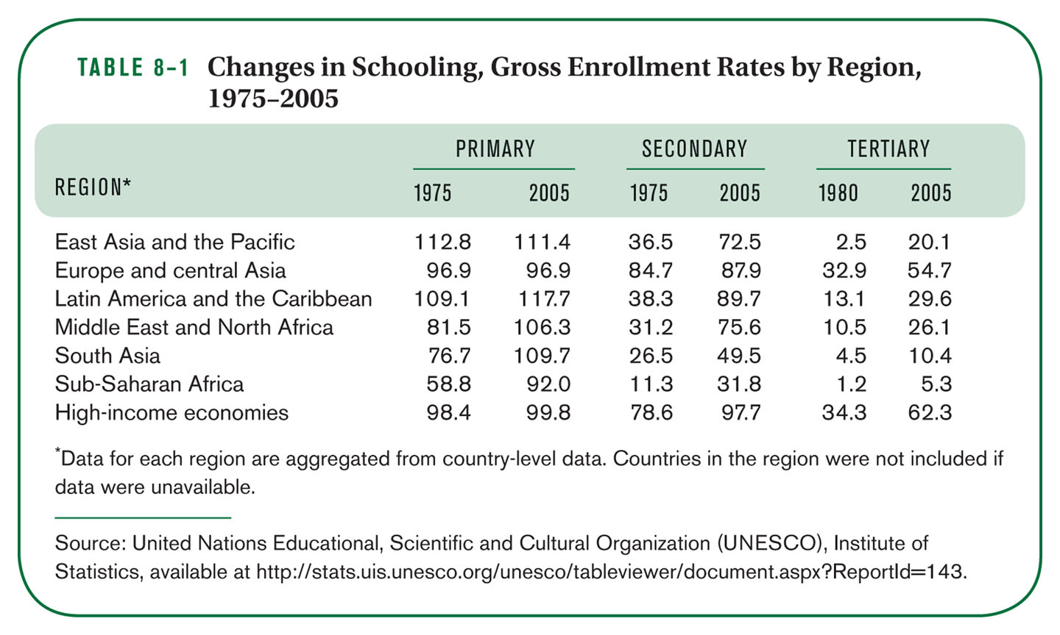

- What is the gross enrollment rate in Latin America and the Caribbean in 2005 for college?

- How are primary gross enrollment rates above 100% for some regions?

- If we looked at high school and college gross enrollment rate in Latin America and the Caribbean for 2018, what do you think they would look like? Explain your answer.

