Name:
Date:

Homework Assignment 1
Latin American Economic Issues
EC 3325

Directions: Answer all of the following questions. Show work when possible. Answer essay questions in complete sentences. You may choose to work in a group of no more than 3 total members. You must upload your assignment to Blackboard by 11:59pm on 2/12. Upload your assignment, click on the “Homework Assignment” tab on our Blackboard class site, then Click on “Homework 1.” If you are working as a group, please upload only one copy with all your names on it. The assignment can either be typed in a word document or a scanned copy of written work. Only three questions will be graded for correctness. Assignments are open note and open book. You should not use information from outside this class on assignments.

- Explain why slavery became popular in Brazil in the 16th century.

- Why is “creative destruction” important to growth.

- Explain how devaluation of LA currency led to many people working “under the table” jobs in cities in LA.

- Fill in the blanks. Be sure to show your work below the table. (Hint: Pay attention to the units.)

Country | GDP (in billions of $’s) | Population (in millions) | GDP per capita ($’s per person)
Zackland | 100 | 300
Cohlesburgh | 200 |  | 4,000
Economics Union |  | 500 | 5,000

- Solve for X, Y, and Z. Show your work.
- Y=X+Z+10
- Z=2X-Y+20
- X=3Y-Z

- Answer the following questions using the graph below:
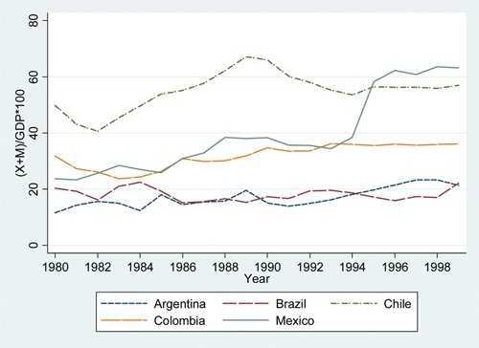
- What is the value of Trade Openness in 1990 in Mexico?

- Which country is the most open to trade during the entire time period?

- Which county is the least open to trade during the entire time period?

- Mexico’s trade openness grew in 1944. What might explain this?

